LAB NO: 3. 24K-0645

Q:1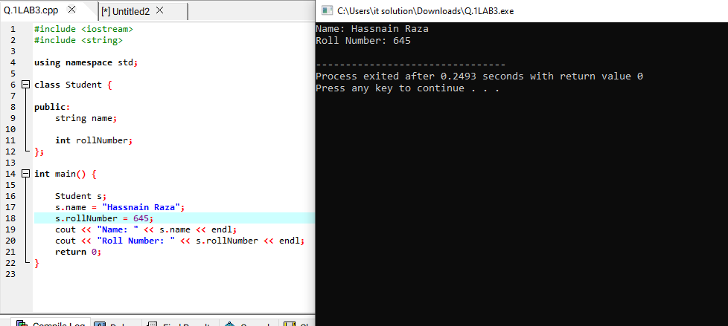

#include <iostream>

#include <string>

using namespace std;

class Student {

public:

string name;

int rollNumber;

};

int main() {

Student s;

s.name = "Hassnain Raza";

s.rollNumber = 101;

cout << "Name: " << s.name << endl;

cout << "Roll Number: " << s.rollNumber << endl;

return 0;

}

**Q:2**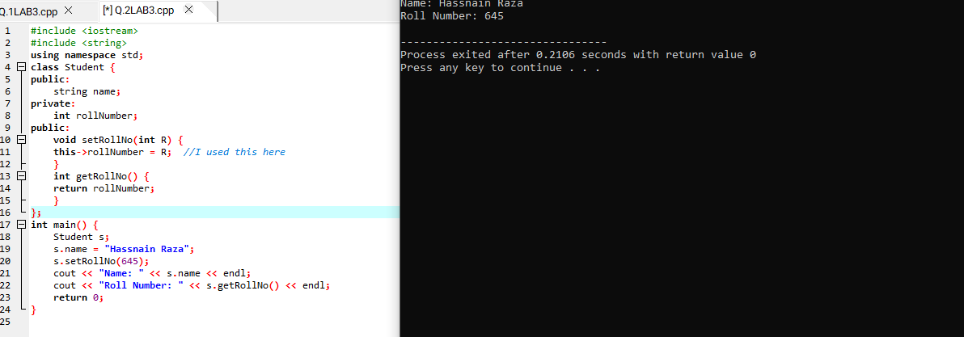

#include <iostream>

#include <string>

using namespace std;

class Student {

public:

string name;

private:

int rollNumber;

public:

void setRollNo(int R) {

this->rollNumber = R; //I used this here

}

int getRollNo() {

return rollNumber;

}

};

int main() {

Student s;

s.name = "Hassnain Raza";

s.setRollNo(645);

cout << "Name: " << s.name << endl;

cout << "Roll Number: " << s.getRollNo() << endl;

return 0;

}

**Q:3**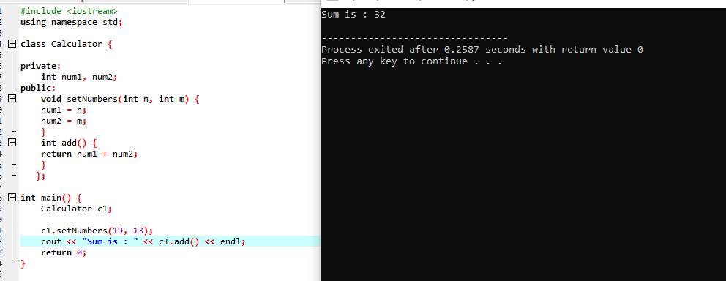

#include <iostream>

using namespace std;

class Calculator {

private:

int num1, num2;

public:

void setNumbers(int n, int m) {

num1 = n;

num2 = m;

}

int add() {

return num1 + num2;

}

};

int main() {

Calculator c1;

c1.setNumbers(19, 13);

cout << "Sum is : " << c1.add() << endl;

return 0;

}

**Q:4**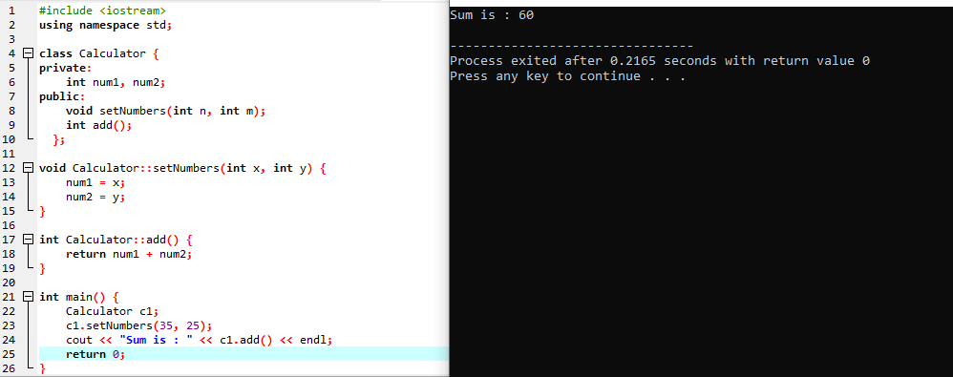

#include <iostream>

using namespace std;

class Calculator {

private:

int num1, num2;

public:

void setNumbers(int n, int m);

int add();

};

void Calculator::setNumbers(int x, int y) {

num1 = x;

num2 = y;

}

int Calculator::add() {

return num1 + num2;

}

int main() {

Calculator c1;

c1.setNumbers(35, 25);

cout << "Sum is : " << c1.add() << endl;

return 0;

}

**Q:5**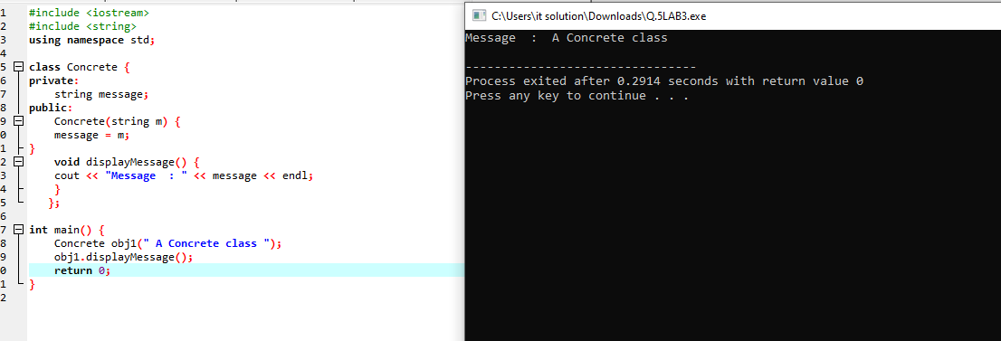

#include <iostream>

#include <string>

using namespace std;

class Concrete {

private:

string message;

public:

Concrete(string m) {

message = m;

}

void displayMessage() {

cout << "Message : " << message << endl;

}

};

int main() {

Concrete obj1(" A Concrete class ");

obj1.displayMessage();

return 0;

}

**Q:6**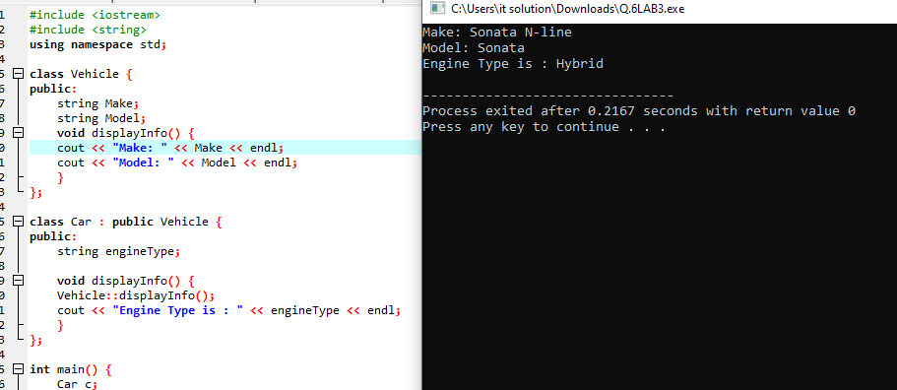

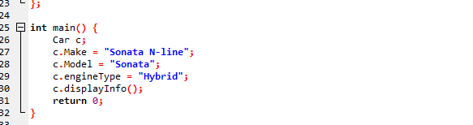

#include <iostream>

#include <string>

using namespace std;

class Vehicle {

public:

string Make;

string Model;

void displayInfo() {

cout << "Make: " << Make << endl;

cout << "Model: " << Model << endl;

}

};

class Car : public Vehicle {

public:

string engineType;

void displayInfo() {

Vehicle::displayInfo();

cout << "Engine Type is : " << engineType << endl;

}

};

int main() {

Car c;

c.Make = "Sonata N-line";

c.Model = "Sonata";

c.engineType = "Hybrid";

c.displayInfo();

return 0;

}

**Q:7**

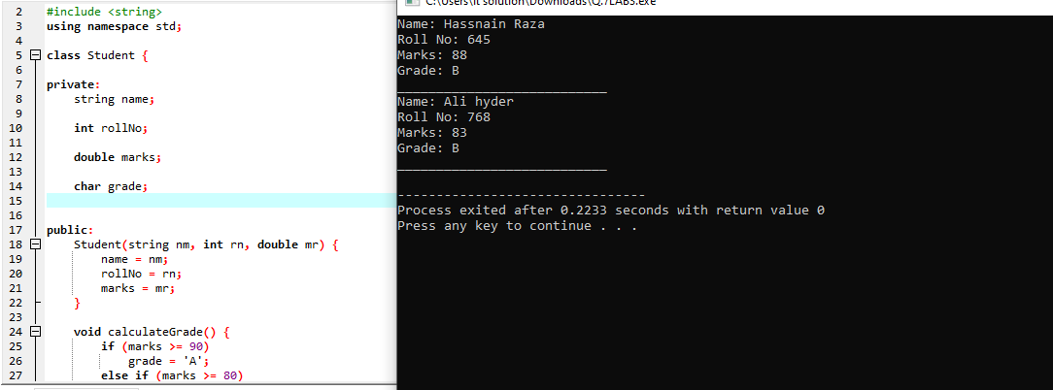

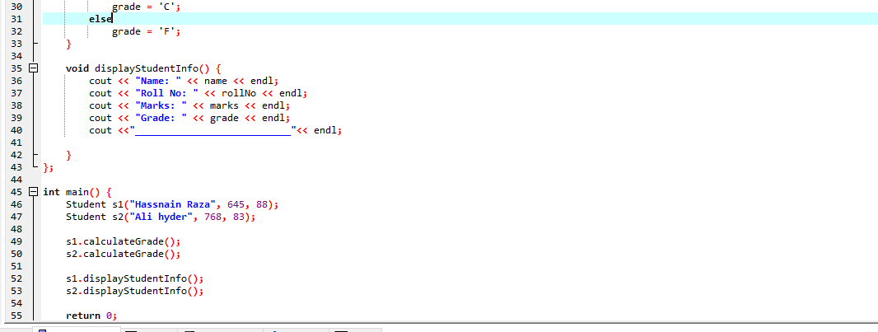

#include <iostream>

#include <string>

using namespace std;

class Student {

private:

string name;

int rollNo;

double marks;

char grade;

public:

Student(string nm, int rn, double mr) {

name = nm;

rollNo = rn;

marks = mr;

}

void calculateGrade() {

if (marks >= 90)

grade = 'A';

else if (marks >= 80)

grade = 'B';

else if (marks >= 70)

grade = 'C';

else

grade = 'F';

}

void displayStudentInfo() {

cout << "Name: " << name << endl;

cout << "Roll No: " << rollNo << endl;

cout << "Marks: " << marks << endl;

cout << "Grade: " << grade << endl;

cout <<"___________________________"<< endl;

}

};

int main() {

Student s1("Hassnain Raza", 645, 88);

Student s2("Ali hyder", 768, 83);

s1.calculateGrade();

s2.calculateGrade();

s1.displayStudentInfo();

s2.displayStudentInfo();

return 0;

}

**THE END**